Week 6
Database Integration and CRUD Operations, covering how the web application stores, retrieves, updates, and deletes data using PHP and MySQL.

1.1 Database Integration

1.1.2 PHP + MySQL Connection
The following code connects PHP to MySQL and is used in includes/db.php:

Fig1.1.2.1
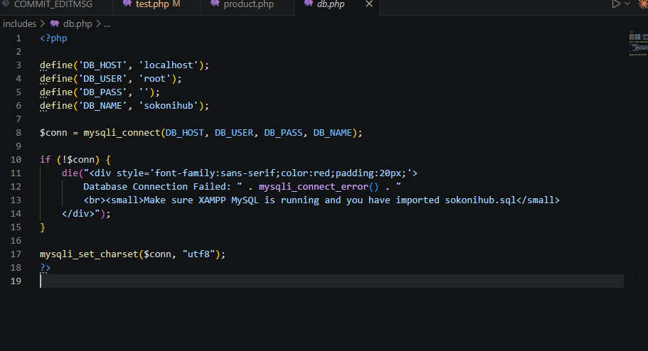

1.2 Class Demonstrations & Activities

1.2.1Creating the Database
The core tables set up this week are:
- users – stores registered customer and admin accounts
- products – stores product listings with price, category, stock
- orders – stores customer orders
- order_items – stores individual product lines per order
- contact_messages – stores contact form submissions
SQL used to create the database:

Fig 1.2.1.1 database sql
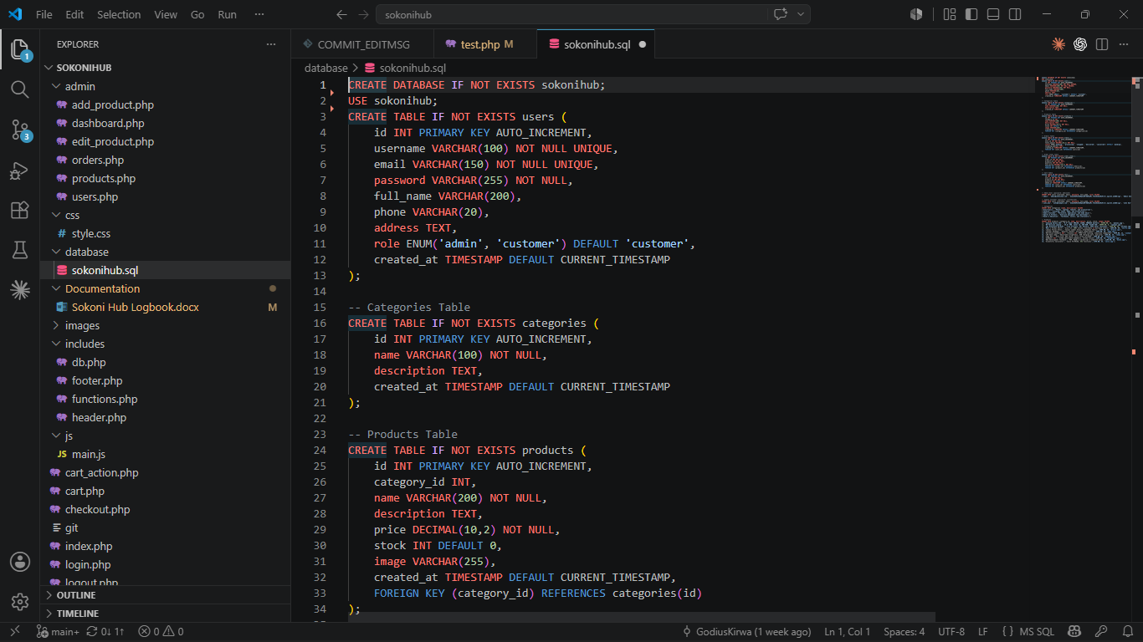

Fig 1.2.1.2Tables List
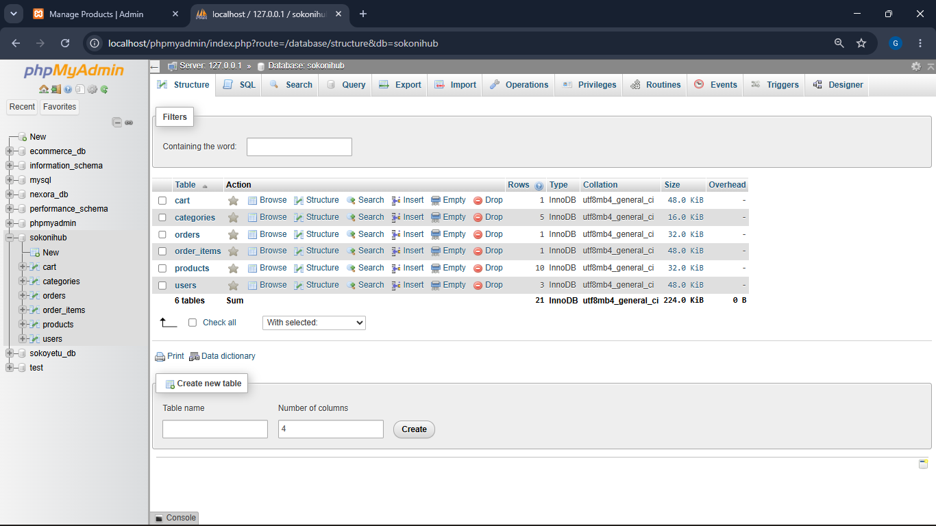

Fig 1.2.1.3 Products Table Structure
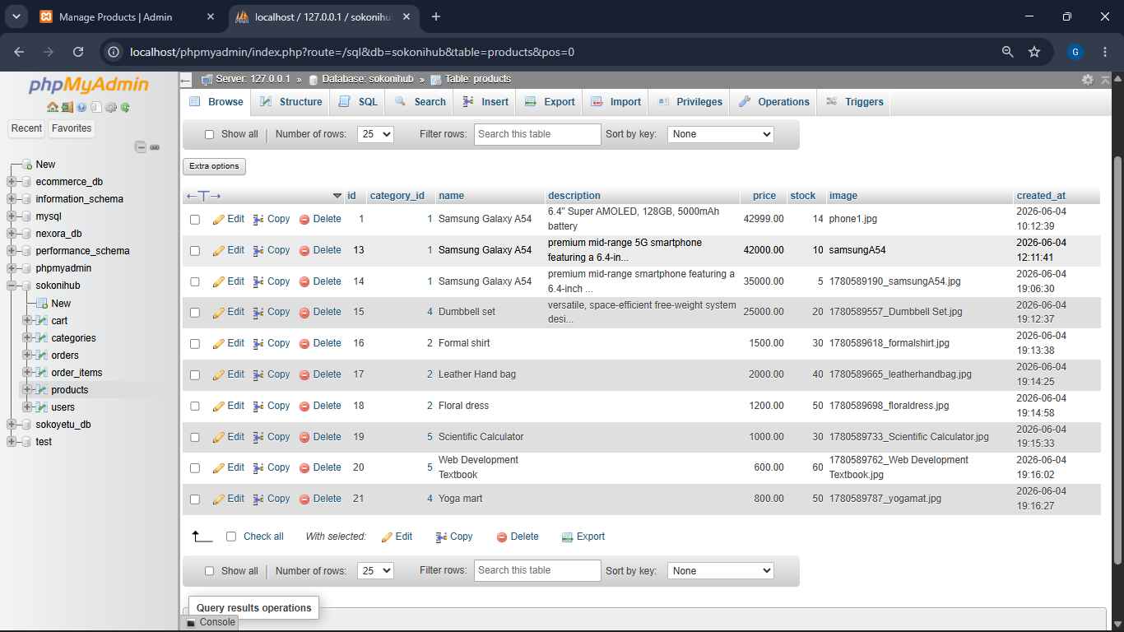
1.3 PHP Database Connection Test

Fig 1.3.1 database connection
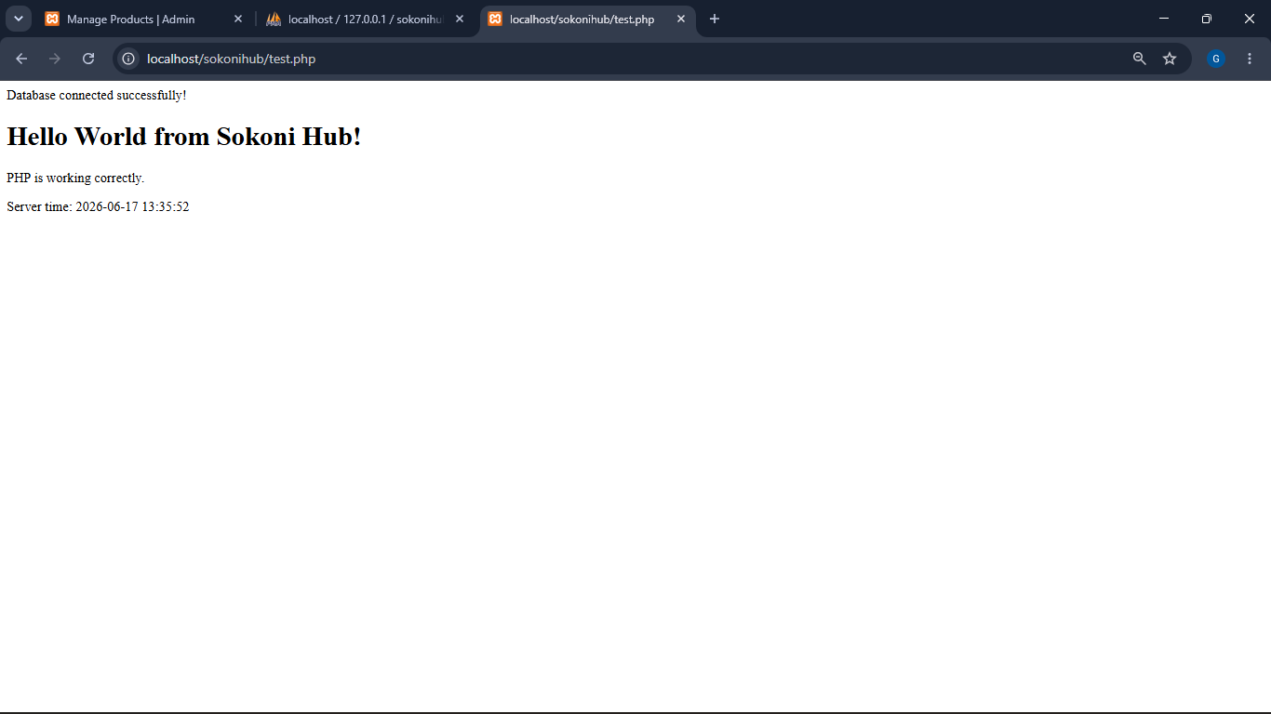

1.3 CREATE Operation (INSERT)
<?php
if ($_SERVER['REQUEST_METHOD'] === 'POST') {
$name = mysqli_real_escape_string($conn, $_POST['name']);
$price = (float)$_POST['price'];
$category = mysqli_real_escape_string($conn, $_POST['category']);
$stock = (int)$_POST['stock'];

$sql = "INSERT INTO products (name, price, category, stock, created_at)
VALUES ('$name', $price, '$category', $stock, NOW())";

if (mysqli_query($conn, $sql)) {
echo 'Product added successfully!';
}
}
?>

Fig1.3.1 Add new product
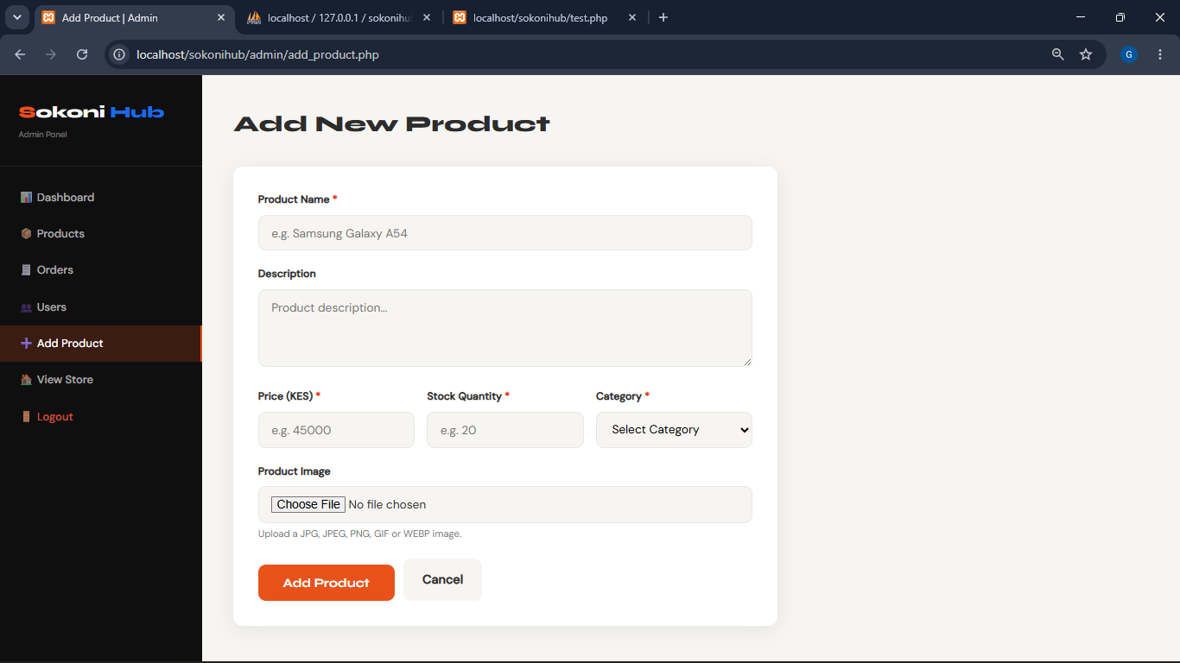

Fig1.3.2 New product in database:
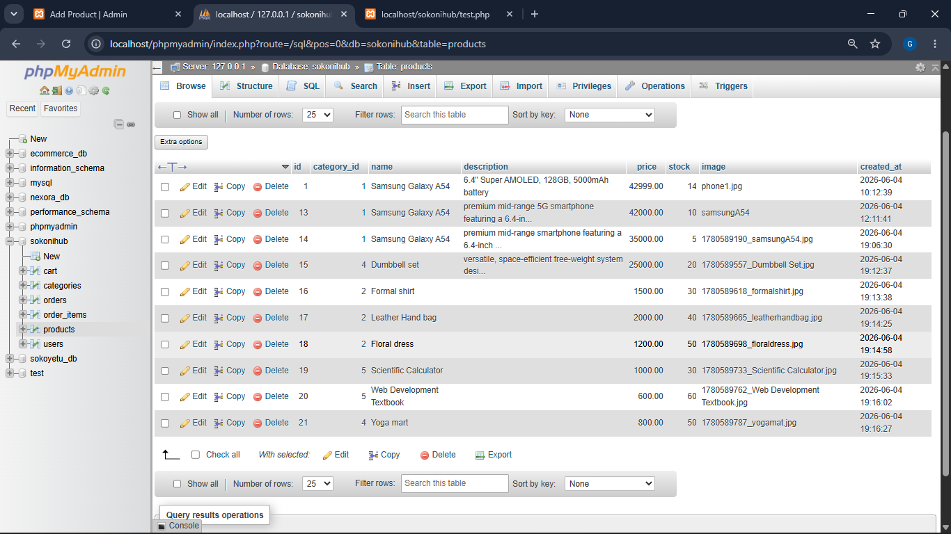

1.4 READ Operation (SELECT)
<?php
$result = mysqli_query($conn, 'SELECT * FROM products ORDER BY created_at DESC');

while ($row = mysqli_fetch_assoc($result)) {
echo '<div class="product-card">';
echo '<h3>' . htmlspecialchars($row['name']) . '</h3>';
echo '<p>KSh ' . number_format($row['price']) . '</p>';
echo '</div>';
}
?>

Fig1.4.1 Products Page Displaying Database Records
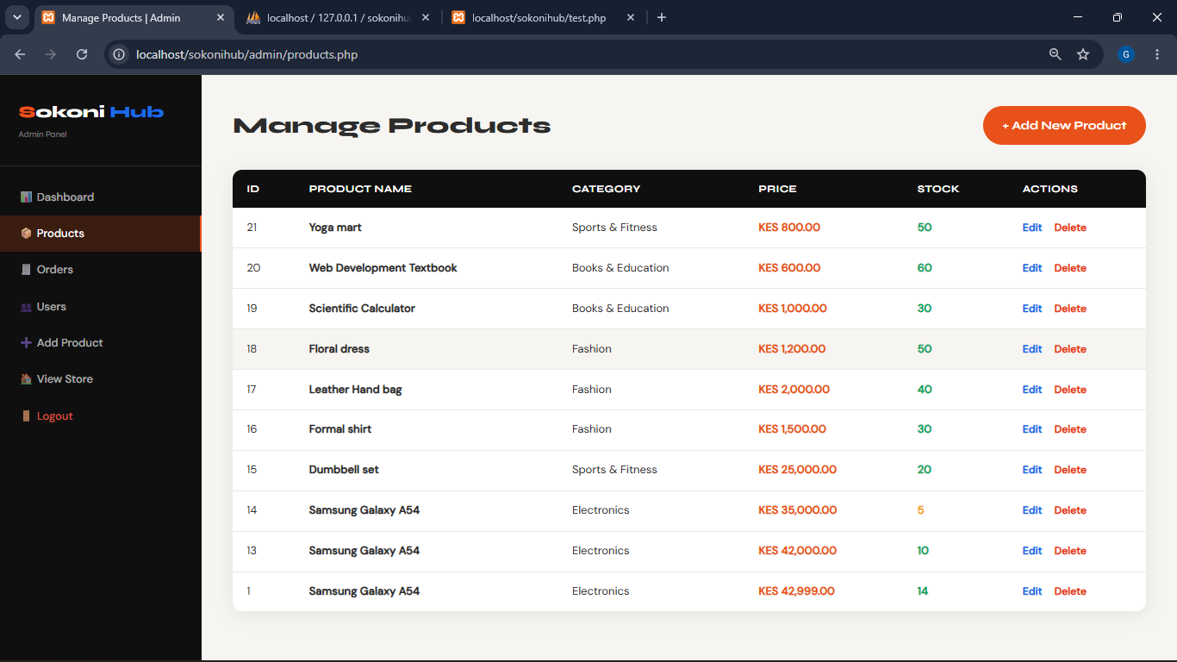

UPDATE Operation
When the admin selects a new status and clicks Save, the following PHP runs:
<?php
if (isset($_POST['update_order'])) {
$order_id = (int)$_POST['order_id'];
$status = mysqli_real_escape_string($conn, $_POST['status']);

$sql = "UPDATE orders SET status = '$status' WHERE id = $order_id";
mysqli_query($conn, $sql);

echo 'Order #' . $order_id . ' updated to: ' . $status;
}
?>
Orders Table with Status Dropdown
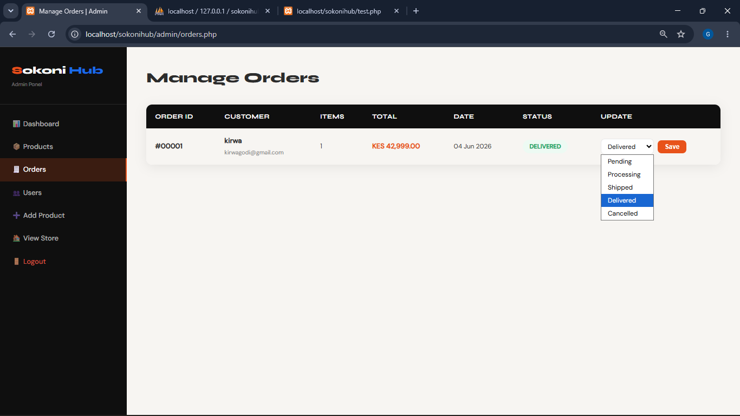

DELETE Operation
When the Delete button is clicked and confirmed, the following PHP executes:
<?php
if (isset($_POST['delete_product'])) {
$product_id = (int)$_POST['delete_product'];
$sql = "DELETE FROM products WHERE id = $product_id";
mysqli_query($conn, $sql);
echo 'Product deleted successfully.';
}
?>
Fig Delete Button on Products Table


Fig

